1
2
3
Preparation of Papers for IPCMC 2022 Conference

1
2
A. Author, B. Author and C. Author
Yildiz Technical University, Department of Civil Engineering, İstanbul, Turkey
email@yildiz.edu.tr, email@ yildiz.edu.tr, email@ yildiz.edu.tr
1
D. Author
Yildiz Technical University, Department of Architecture, İstanbul, Turkey
email@ yildiz.edu.tr
1
2

Abstract
1
These instructions give you guidelines for preparing papers for IPCMC 2022. Abstract and paper must be in English language. Use this document as a template if you are using Microsoft Word 6.0 or later. Otherwise, use this document as an instruction set. The electronic file of your paper must be in this format. Define all symbols used in the abstract. Do not cite references in the abstract. Maximum word shall not exceed 200 words.
1

Keywords: keywords or phrases in alphabetical order, separated by commas.
1
2

Introduction
1
When you open IPCMC2022.doc, highlight a section that you want to designate with a certain style, and then select the appropriate name on the style menu. The style will adjust your fonts and line spacing. Do not change the font sizes or line spacing to squeeze more text into a limited number of pages. Use italics for emphasis.
1
To insert images in Word, position the cursor at the insertion point and either use Insert | Picture | From File or copy the image to the Windows clipboard and then Edit | Paste Special | Picture (with “Float over text” unchecked).
1
2

Procedure for Paper Submission
1
Please submit your manuscript by electronically for review. Follow the online submission guidelines when submitting. Please give all the required details.
1
Include full mailing addresses and e-mail addresses. This information will be used with the communication of the authors. All tables, figures and pictures must be inserted in the text in a convenient place.
1

1
The paper size must be set to A4 (210x297 mm). The document margins should be the following:
- Top: 2.5 cm;
- Bottom: 2.5 cm;
- Left: 2.5 cm;
- Right: 2.5 cm.
It is advisable to keep all the given values. The font throughout the paper is Times New Roman with 12 point font style, justified in one column. The title font is 16 point bold style, centered. Authors’ font is set to 14 point bold style, address 12 point bold and italic style. Email address 12 point italic style. Abstract and keywords section is justified with a font of 12 point italic style. The number of pages shall not exceed 12 pages.
1
2
Equations
1

Use the Microsoft Equation Editor for equations in your paper (Insert | Object | Create New | Microsoft Equation). “Float over text” should not be selected.

1
$U_{i}=\sum_{j}{w_{j}u_{\text{ij}}}$ (1)

1

2
Results

1
Figures and Tables
1
Figures: Position of figures is centered. Place figure captions below the figures with 12 point Times New Roman centered. If your figure has two parts, include the labels (a) and (b) as part of the artwork. Please do not include captions as part of the figures. Do not put captions in “text boxes” linked to the figures. Do not put borders around the outside of your figures.
1
Figure axis labels are often a source of confusion. If label numbers are in thousands of orders, use scientific numbering to represent them. Use words rather than symbols. Do not label axes only with units. Figure labels should be legible, 10 point type.
1
Table: Position of tables is centered. Place table captions above the tables with 12 point Times New Roman centered. Please do not include captions as part of the table. Do not put captions in “text boxes” linked to the table.
Text and numbers size should be, 12 point.
1

Table 1. This caption is centered.
1
 | Column 1 | Column 2
Raw 1 | 60483.84 | 31518.54
Raw 2 | 3428.56 | 4475.90
1
1
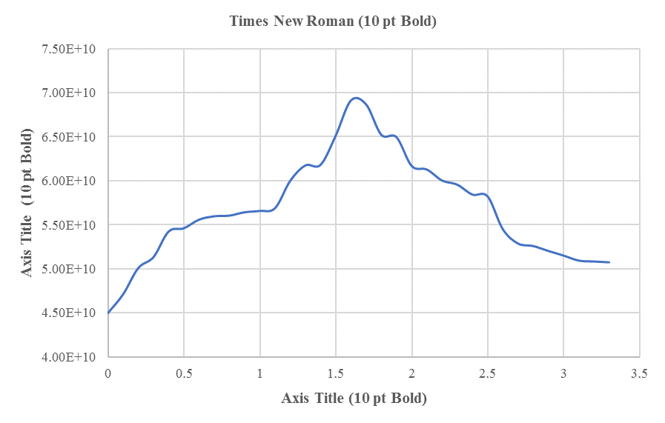
1
Figure 1: This caption is centered.
1
2

References (APA Style)
1
Aladağ, H., & Işık, Z. (2018). The effect of stakeholder-associated risks in mega-engineering projects: A case study of a PPP airport project. IEEE Transactions on Engineering Management, 67, 174-186.
1
Birgönül, M. T. & Dikmen, İ. (1995a). "Life Cycle Cost and Risk Management", Developments in Civil Engineering, Proceedings of II. Technical Congress, Boğaziçi University, Istanbul, 589-599.
1
Birgönül, M. T. & Dikmen, İ. (1995b). “A Methodology for the Evaluation of Proposals Tendered on the Basis of Build-Operate-Transfer (BOT) Model”, In ARCOM 12th Annual Conference, Sheffield, England, Vol. 1, 140-149.
1
Demirdöğen, G., Işık, Z., & Arayıcı, Y. (2021). Facility management information taxonomy framework for queries in healthcare buildings. Journal of Building Engineering, 44, 1-19.
1
Fraser, P., Moultrie, J., & Gregory, M. (2002). The use of maturity models/grids as a tool in assessing product development capability. In IEEE International Engineering Management Conference, Vol. 1, pp. 244-249.
1
Hartmann, T., Van Meerveld, H., Vossebeld, N., & Adriaanse, A. (2012). Aligning building information model tools and construction management methods. Automation in Construction, 22, 605-613.
1
Sacks, R., Eastman, C., Lee, G., & Teicholz, P. (2018). BIM Handbook: A Guide to Building Information Modeling for Owners, Designers, Engineers, Contractors and Facility Managers. John Wiley & Sons.
1
Quinion, M. B. (1998). Citing online sources: advice on online citation formats. http://www.worldwidewords.org/articles/citation.htm. Date of access: 05.03.2017.

